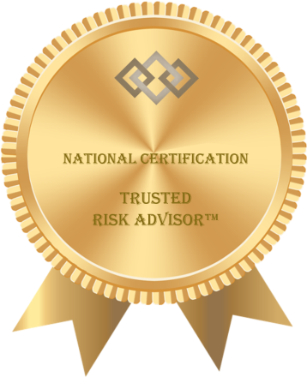

**Certificate of Achievement**

This certifies that:

John Doe

has successfully completed the Trusted Risk Advisor™ program and is hereby certified to use the TRA mark and the title of Trusted Risk Advisor™.