Resources to Use in Promoting Your Certification

Now that you have completed all four Trusted Risk Advisor™ courses, you are permitted to market or promote yourself as certified using the following description:
"(Participant’s name) is a certified Trusted Risk Advisor™."
The Program Title, “Trusted Risk Advisor™," and the Program Mark, “TRA™,” may be used in any size and in conjunction with your own marketing materials. You are encouraged to use the Program Title, Program Mark, and Seal for letterhead, business cards, envelopes, note cards, email signatures, advertising, and other marketing collateral material.
Any unauthorized use of the Program Titles, Marks, Logos, or Seals can deceive customers and dilute the value of the Program Marks; therefore, the Program Marks must be used only in a manner and to the extent specifically authorized by Beyond Insurance.

Transfer of Program Title and Mark is strictly prohibited. By using this private website, you are agreeing not to loan, transfer, convey, lease or sell the Program Title, Mark, or Seal to any third party.

Beyond Insurance specifically prohibits the use of the Program Marks or any variation of the Program Marks in any internet domain names or e-mail addresses, except those provided by Beyond Insurance to participant. Beyond Insurance reserves the right to obtain the transfer of any unauthorized domain name upon request and without reimbursement.

Approved Use in Social Media
You may use any or all of the language below on social media profiles:
TRA: the Mark of Credibility. The Trusted Risk Advisor certification distinguishes you for your risk advisory expertise and capabilities and shows that you have mastered the art of consulting, diagnosing, and treating risk. It demonstrates that you are skilled at reducing claim frequency and severity.
Examples of LinkedIn profiles showing the mark and seal are available on this site.

Gold Seal
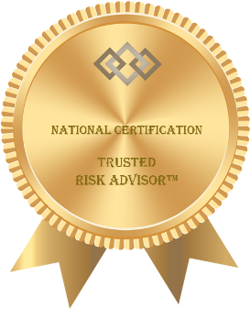
You are encouraged to use the TRA gold seal of achievement in social media and with your email signature.

Certificate of Achievement
Beyond Insurance has provided a Certificate of Achievement that you may personalize with your name.
You are encouraged to place the certificate on your social media profile and/or frame and hang it prominently in your office.

LinkedIn Profile Suggestions
Two LinkedIn profile suggestions are shown on the site, demonstrating ways to promote your certification and the gold seal of achievement.

Questions or Comments?
Please contact Carolyn Smith with any questions or comments:
Carolyn Smith
Beyond Insurance
csmith@beyondinsurance.com
484-704-9505

